**Experiment No.: 3**

**Aim**

Familiarisation of Linux commands

**CO2**

Perform System Administration tasks.

**Procedure**

**1.pwd(Print Working Directoy)**

To find out the path of the current working directory

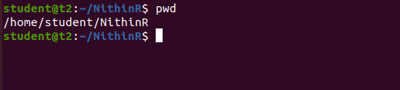

**2.ls**

The ls command is used to view the contents of a directory.

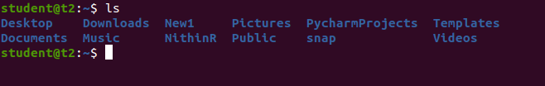

**3.ls -R**

ls -R will list all the files in the sub-directories as well

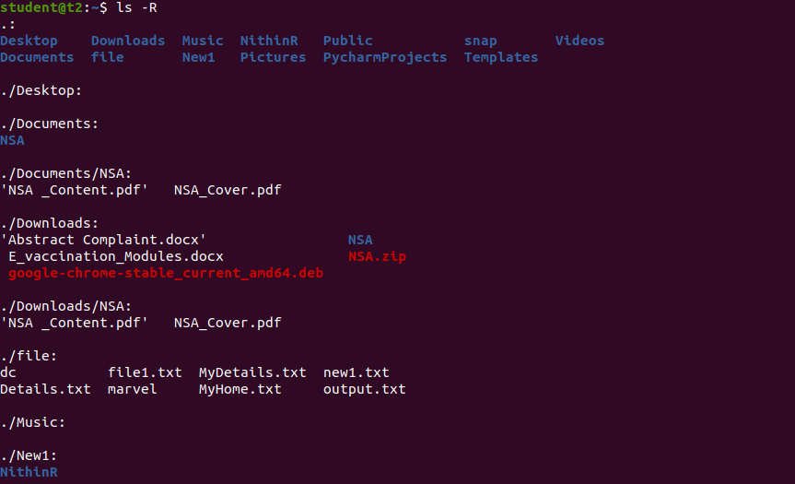

**4.ls -l**

s –l – long listing

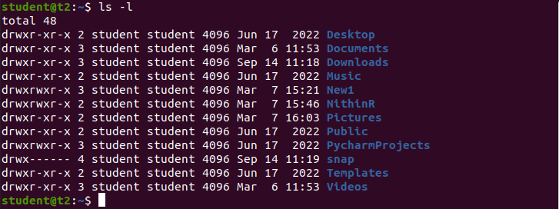

**5.ls -a**

ls -a will show the hidden files

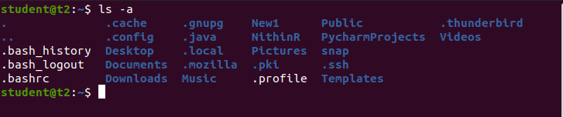

**6.ls -al**

ls -al will list the files and directories with detailed information like he permissions, size, owner, etc.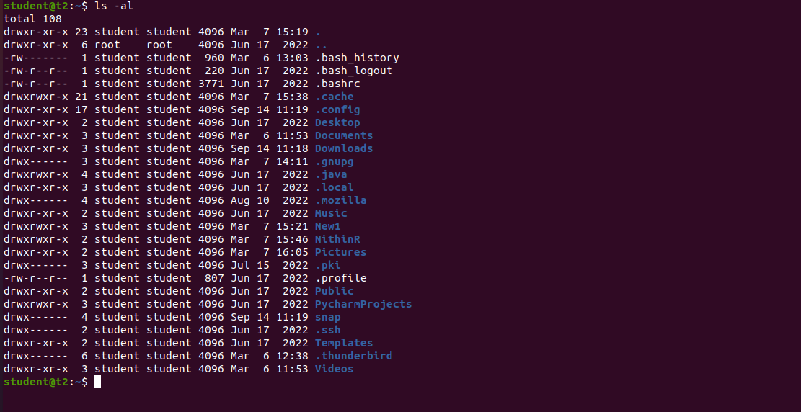

**7.ls -t**

ls -t lists files sorted in the order of “last modified”

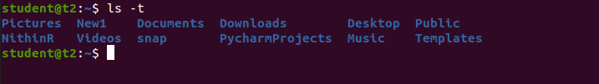

**8.ls -r**

ls -r option will reverse the natural sorting order. Usually used in combination with other

switches such as ls -tr. This will reverse the time wise listing.

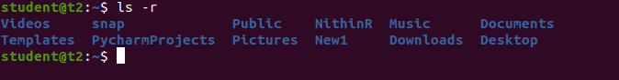

**9.history**

To review the commands you have entered before. !command number to run a

command from history.

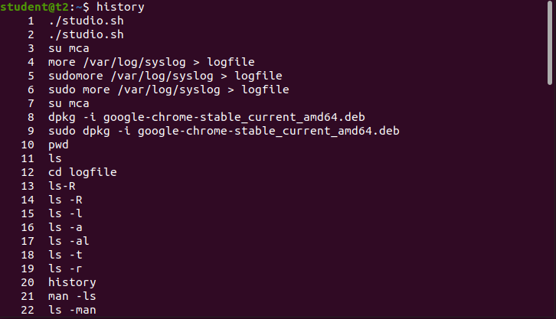

**9.man ls**

This will show the manual instruction of the command.

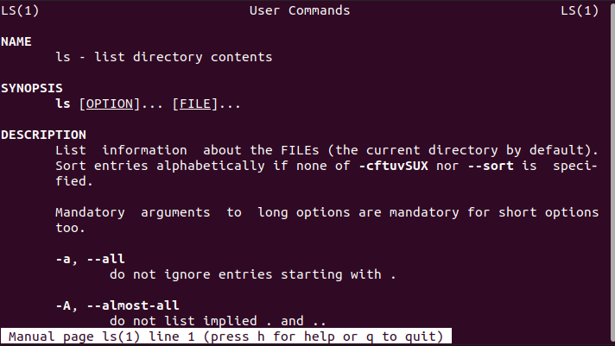

**10.mkdir**

Use mkdir command to make a new directory. Use the p (parents) option to create

a directory in between two existing directories.

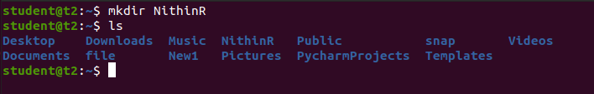

**11.rmdir**

The "rmdir" command is used to remove or delete an empty directory in a file system from the command line or terminal.

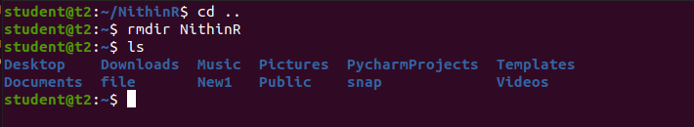

**12.touch**

The touch command allows you to create a blank new file through the

Linux command line.

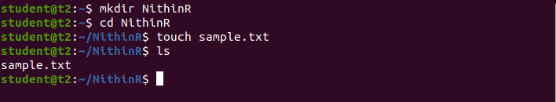

**13.cat >File1.txt**

To Create a File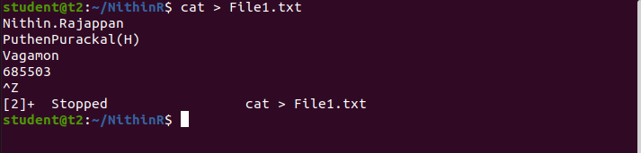

**14.cat File1**

This command will displays the contents of a file in the terminal.

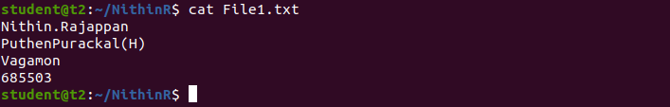

**15.cat >> File1.txt**

This command will append (add something in the last of a file) something in your already existing file.

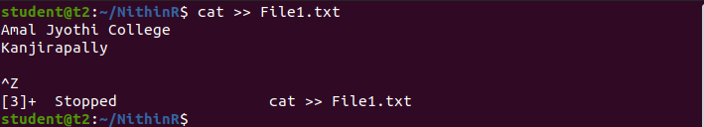

**16.cat -e**

The cat -e command displays the contents of a file with special characters and line

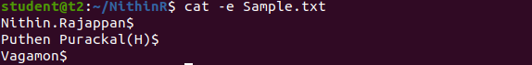

**17. cat -n**

This command will display the contents of a file in the terminal, with line numbers displayed before each line.

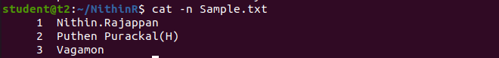

**18.cat a b**

This command displays the contents of both files in the terminal, with the contents of file "a" displayed first, followed by the contents of file "b".

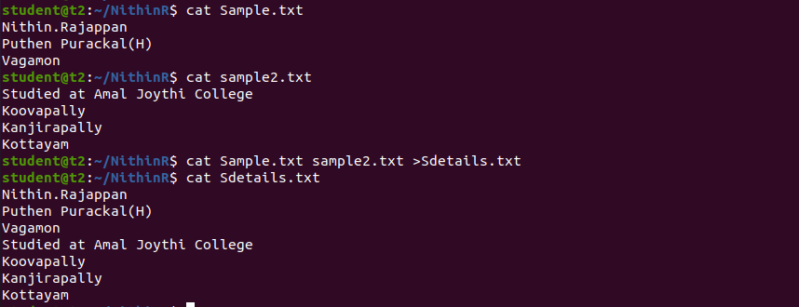

**19. cut -b1**

This command is used to extract the first byte or character of each line from a file or output, where "b" stands for "byte" and "1" refers to the first byte or character position.

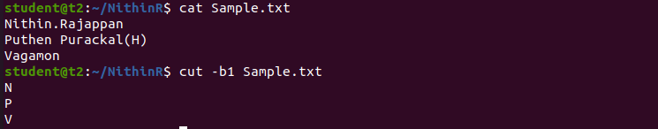

**20. cut -b2**

This command is used to extract the second character or column of each line from a file or output, where "b" stands for "byte" and "2" refers to the third character or column position.

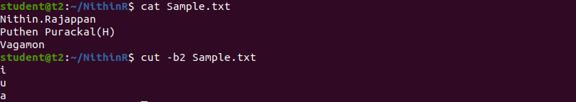

**21c. cut -c3**

This command is used to extract the third character or column of each line from a file or output, where "c" stands for "character" and "3" refers to the third character or column position.

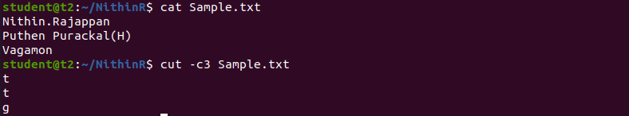

**22. tr a-z**

To convert the content into Capital Letters

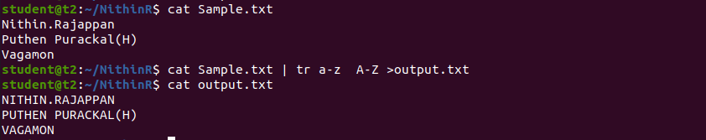

**23.paste**

paste contents of one file to other

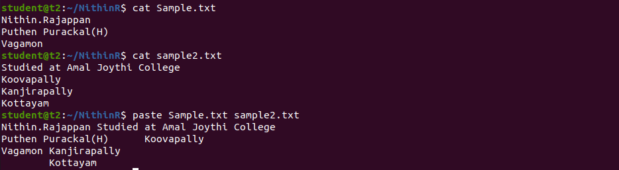

a)paste contents of two files into a third file

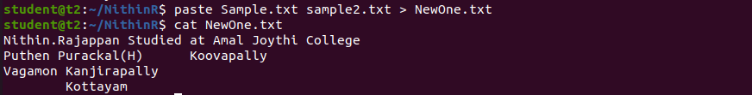

**Result**

The program was executed and the result was successfully obtained. Thus CO2 was obtained.